Create a database named 'custom'. Create a table named temperature_data inside custom having below fields:

1. date (mm-dd-yyyy) format 2. zip code 3. temperature The table will be loaded from comma-delimited file. Load the dataset.txt (which is ',' delimited) in the table.
2. Creating data base and use that DB for creating table.



USE custom.

1. Create table.

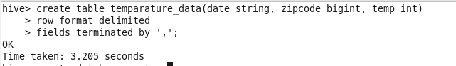

1. Load data from local.

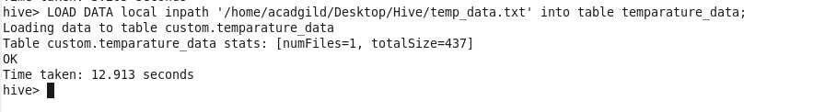

1. View loaded data;

